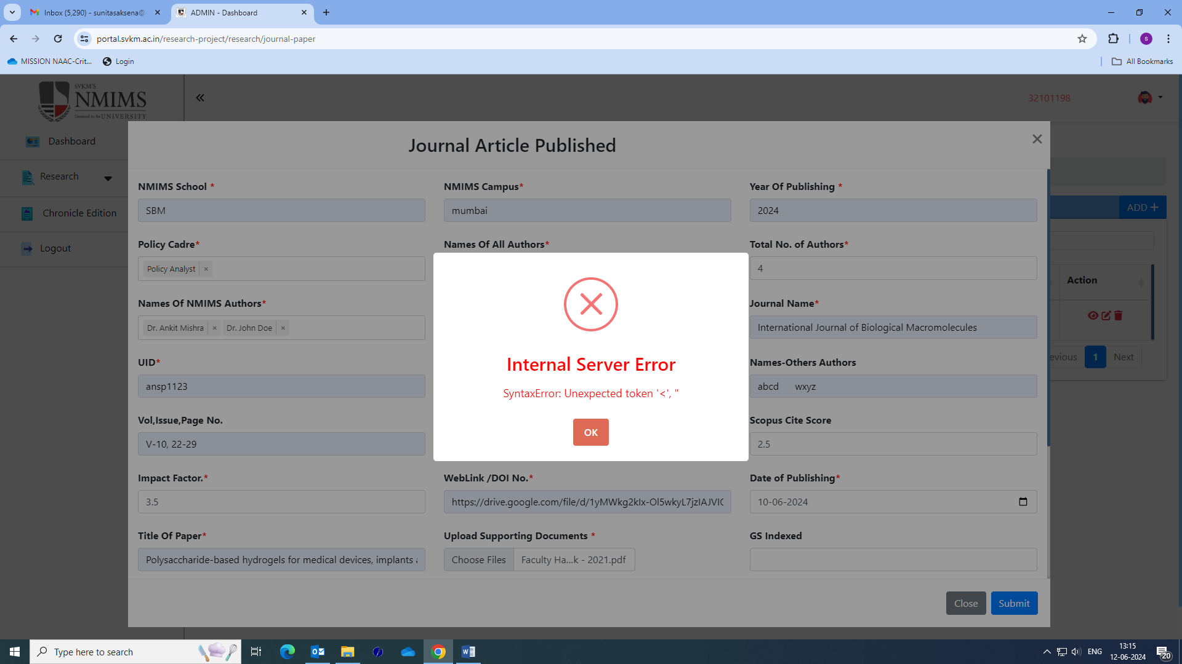

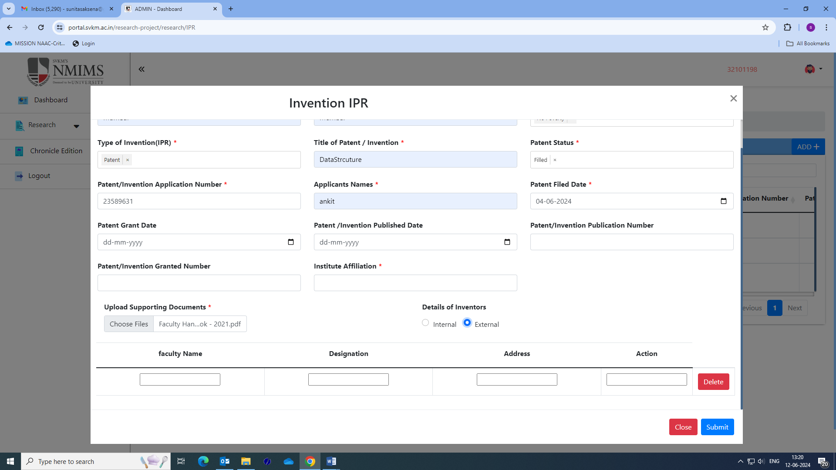

What is action? We discussed to include institution name

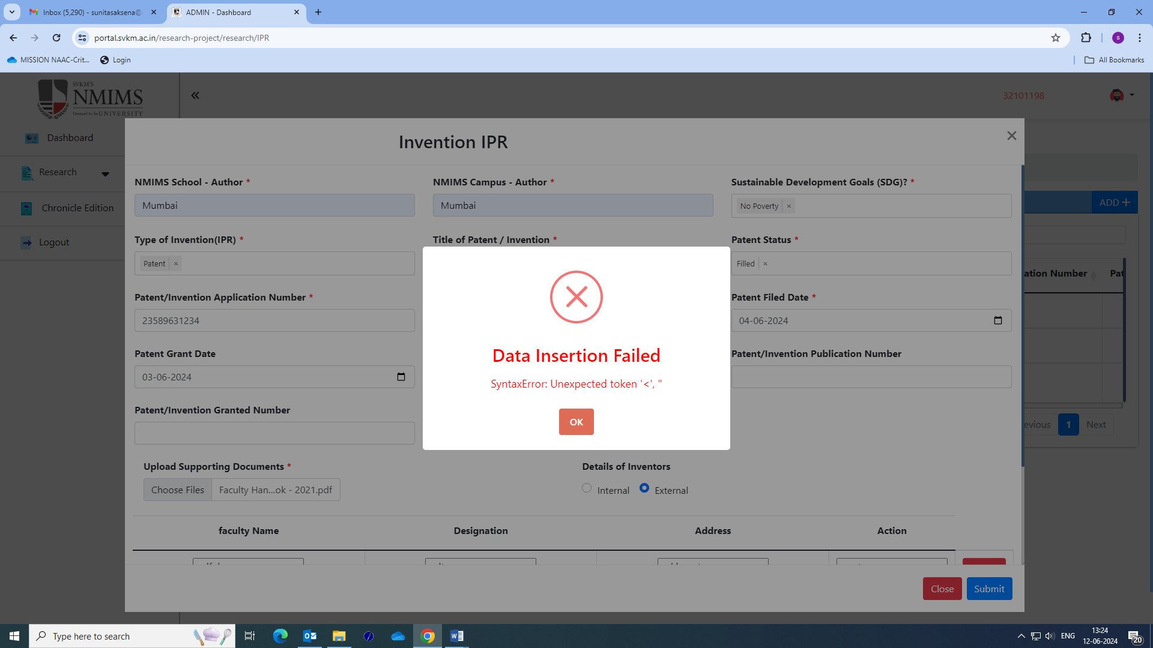

**Cannot submit Employee ID for EXTERNAL author**

**Cannot submit Employee ID for EXTERNAL author**

**Cannot submit Employee ID for EXTERNAL author.**

**Patent grant date, patent published date, patent publication number, patent granted number is not mandatory field**